: השעה - 1) The time
https://www.youtube.com/watch?v=RBvmO7NgUp0
https://www.youtube.com/watch?v=tEmg914-9xY
:2) Activity about the time
The teacher will bring a clock and ask the pupil what's the time.
For example:
It's __six (6)____ o'clock. (The pupil will answer)
3) A worksheet to complete with the pupil and/ or at home.
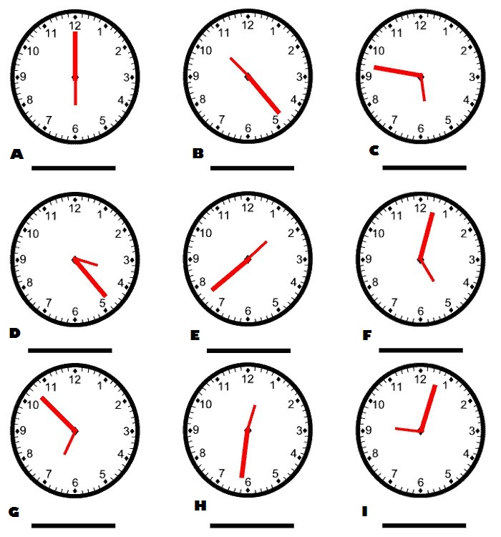

It's 6 (six) and a half.
It's 5 (five) o'clock.
The pupil will do whatever he's capable of. Each lesson he will advance.
The important thing is to challenge him and to improve his self confidence in requiring a new language.
4) The time game:
https://www.gamestolearnenglish.com/telling-the-time/

